# Minutes for CSC2058 Project: 25 Minutes Week commencing: 15/2/2021

# Date of this minute­­­­­: 15/2/2021

The following team members were present on Teams (if not Teams, indicate platform) when minutes were discussed:

|  |  |
| --- | --- |
| Name (printed/typed) | Signature (agreed bitmap or initials) |
| Daniel Mason | DM |
| Niamh McLarnon | NML |
| Craig Mulligan | CM |
| Michael Kennedy | MK |
| Omar Ahmed Hassan Abdelfattah Bashah | OB |
| Charlotte Bisp | CB |

Task Reporting (Briefly list the progress for each team member in the last week.*)

Name (Daniel):

* Worked on code (add more of the basic functionalities, close to completing all basic functionalities)

Name (Niamh):

* Started working on testing documentation
* Minor updates to code

Name (Craig):

Name (Michael):

Name (Omar):

Name (Charlotte):

Actions Planned (Briefly list the actions required of each team member for the next week.)

Name (Daniel):

* Finish basic functionalities of code
* Make action areas work

Name (Niamh):

* Start Text user interface
* Continue on testing documentation

Name (Craig):

Name (Michael):

Name (Omar):

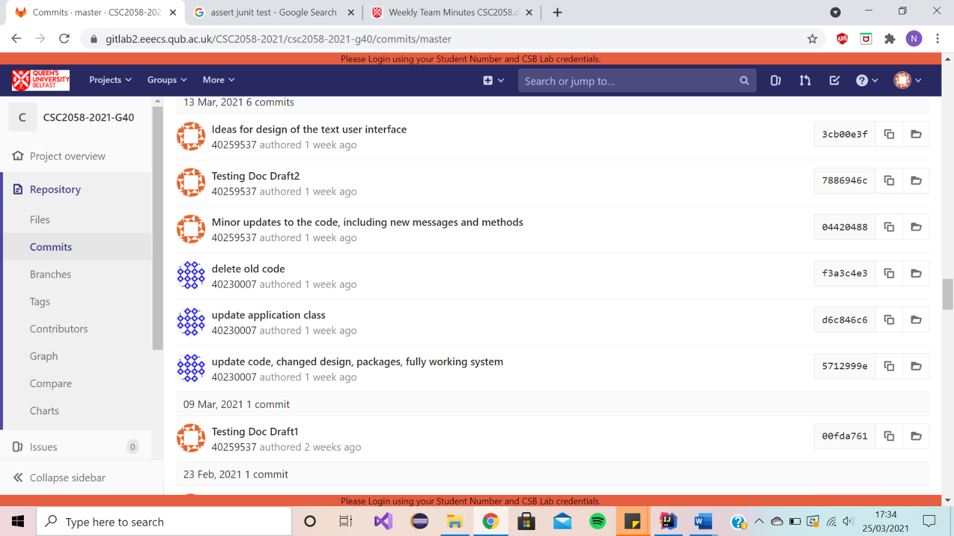

Name (Charlotte):